**AUTOMATED UNIVERSITY NETWORKING**

***Submitted by***

**BL.EN.U4AIE20027  ------ K.Akhilesh**

**BL.EN.U4AIE20034   ------  M.Venkata.Dhanumjaya**

**BL.EN.U4AIE20035   ------ M.Nitish Narayan**

**19AIE211 – Introduction to Computer Networks**

**B.Tech. in Computer Science and Engineering (Artificial Intelligence)**

**AMRITA SCHOOL OF ENGINEERING, BANGALORE**

**AMRITA VISHWA VIDYAPEETHAM**

**BANGALORE 560 035**

**June – 2022**

**Table Of Contents**

|  |  |  |
| --- | --- | --- |
| **S. No** | **Topics** | **Page. No** |
| **1** | **Abstract** | **3** |
| **2** | **Introduction** | **3** |
| **3** | **Literature Survey** | **4** |
| **4** | **Methodology** | **4-5** |
| **5** | **Design** | **5-9** |
| **6** | **Implementation** | **9-10** |
| **7** | **Results** | **10-15** |
| **8** | **Conclusion** | **16** |
| **9** | **Future Scope** | **16-17** |
| **10** | **References** | **17** |

**Abstract**

Computer network has become the most significant issue in our day-to-day life. In this presentation we are going to present you about AUTOMATED UNIVERSITY NETWORKING.

The network is designed using Cisco Packet Tracer.

In our project we describe how the tool (CPT) can be used to develop a simulation model of the University. The University Area Network design is about designing a topology of a network for a university in which various computers of different departments and buildings are set up so that they can interact and communicate with each other by interchanging data. Also, the wireless operation of various IOT appliances has been implemented in this paper

**Introduction**

Cisco Packet Tracer (CPT) is multi-tasking network simulation software that can be used to

perform and analyze various network activities such as the implementation of different topologies. selection of optimum path based on various routers, analysis of different network configurations. This University Area Network Scenario is about designing a topology of a network that is wide Area Network (WAN) for a university area in which different department has some computers in different buildings set up their network so that they can interact and communicate with each other by interchanging data .connecting students with the university, faculty, and the library. Most universities today use the network to provide online education by connecting widely dispersed students with their professors directly. For this reason, computer networks play a vital role in the education area by providing efficient communications for the university environment.

**Literature Survey**

Home gateway is the main controller to control the IoT devices. It is very handy to use. It has a password and SSID for the wireless devices to access this.

Implementing Smart College Using CISCO Packet Tracer7.2 Simulator Rania A. Tabeidi*, Samia M. Masaad**, Buthayna G. Elshaikh*** *( Imam Abdulrahman Bin Faisal University, College Of Science & Humanities, Computer Science department, **( Imam Abdulrahman Bin Faisal University, College Of Science & Humanities, Computer Science department, ***( Imam Abdulrahman Bin Faisal University, Deanship of Preparatory Year and Supporting Studies, Department of basic sciences Corresponding Author: Rania A. Tabeidi

**Methodology**

* For the wireless networking, we have used Home gateway to control IoT devices.

🡪SBC and MCU board are also used to control IoT devices.

**Home Gateway:**

First one IP address will be automatically assigned to it. If multiple gateways are created then we are required to give some different IP addresses in gateway in LAN section. Then we should also give the SSID and password with WPA2 PSK phrase option. After that if a IoT device want to connect with home gateway then we have to select home gateway in settings. Atlast in IoT device wireless settings the SSID and password of home gateway has to be given.

**SBC and MCU boards:**

IoT devices are connected to these with the help of Gpio pins [d0,d1,d1…]. Then we have to create a project with programming language and code has to be given. These boards can also be connected to home gateway wirelessly with SSID and password.

Then these boards control IoT devices by reading and writing the Gpio input as 0 or 1.

**Design**

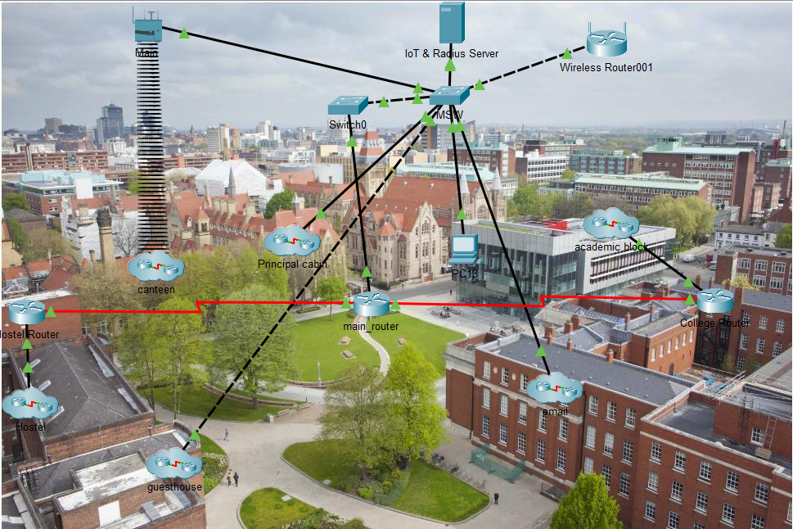

**Principal’s cabin**

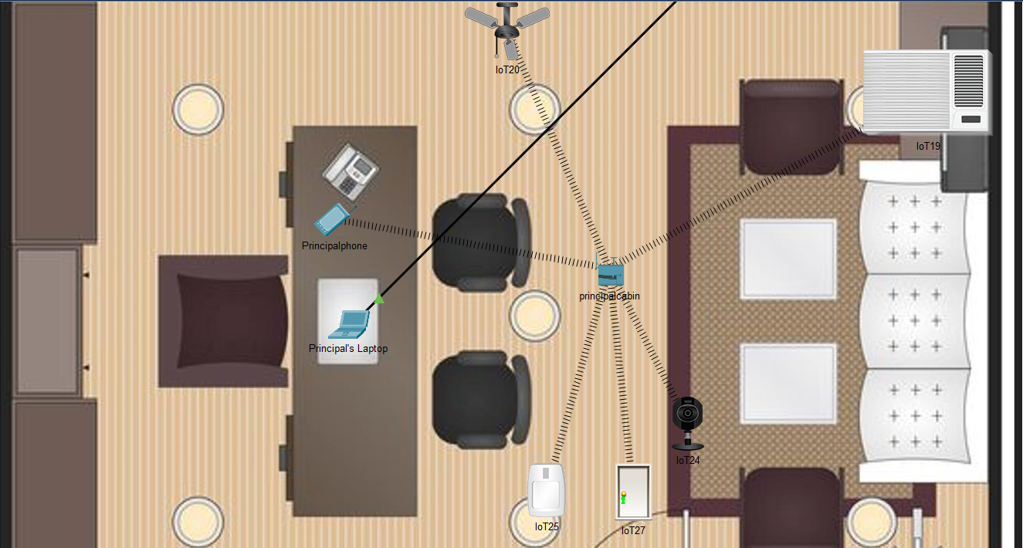

**Cafeteria**

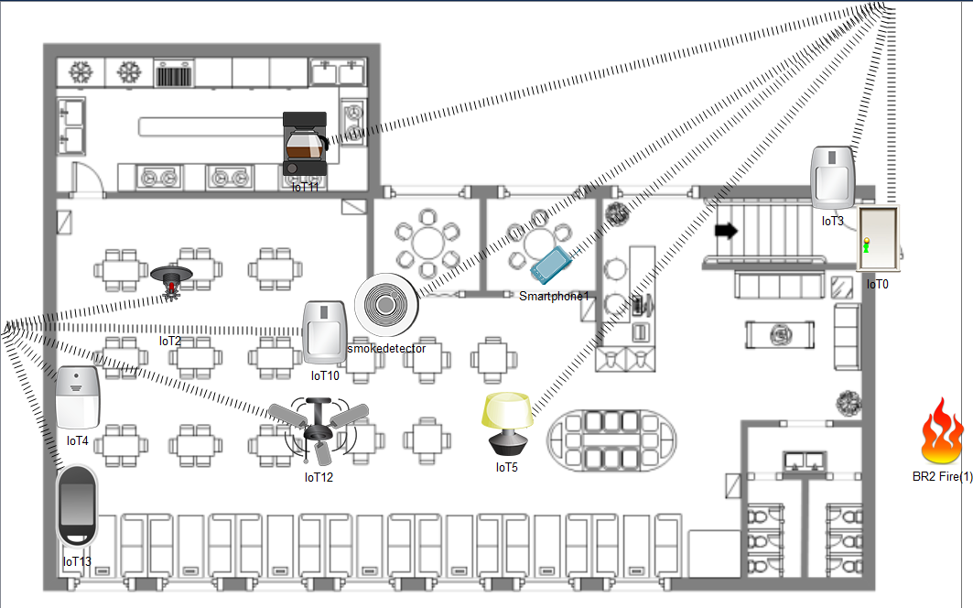

**Academic Block**

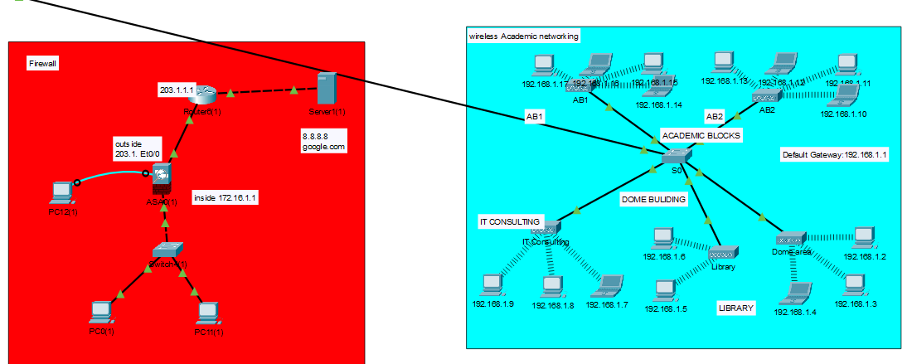

**Implementation**

* Server, Router and Switch
* Principals laptop(admin pc)
* Pc’s and Laptops
* Access points
* Home Gateway
* SBC and MCU boards
* IoT devices

**Results**

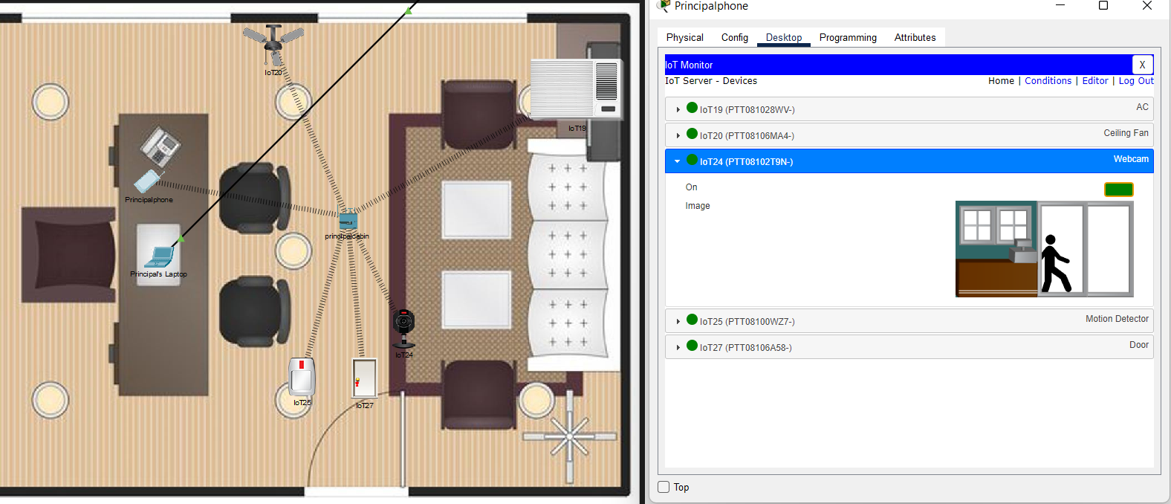

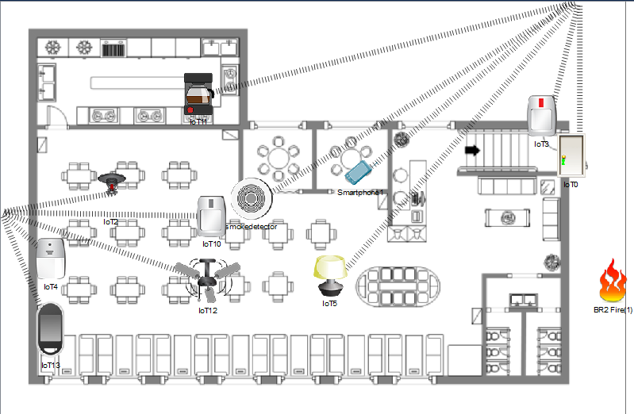

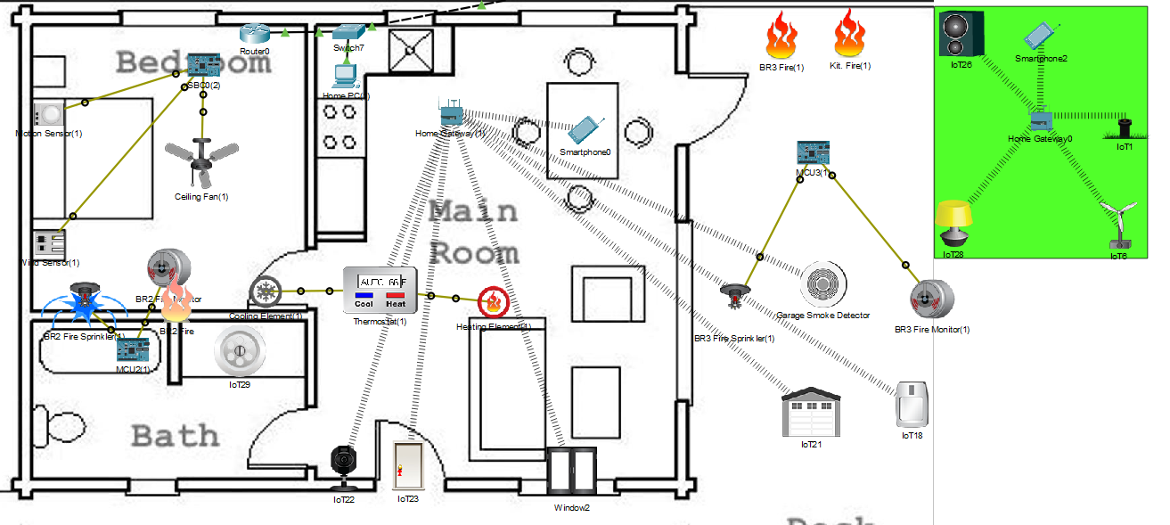

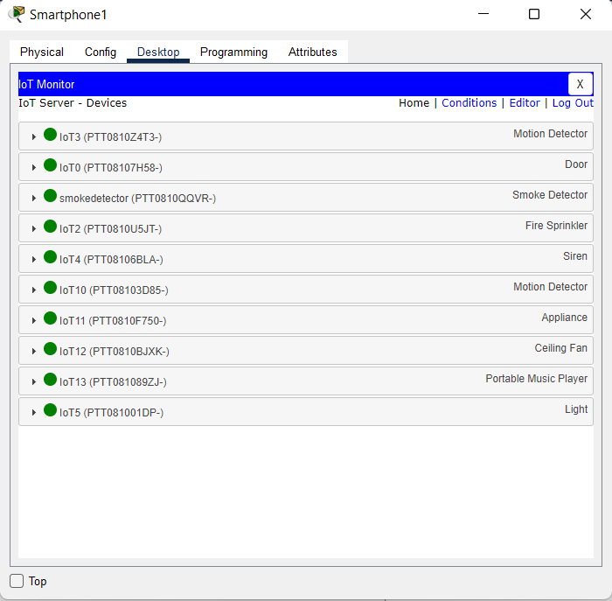

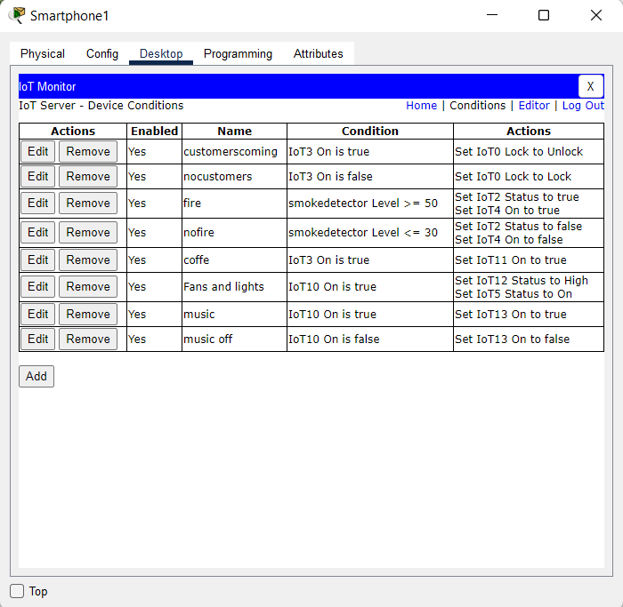

**Conclusion**

All the IoT devices can be controlled with a mobile phone and can also be directly automated without user interference. Every room can be under the monitoring of principal. Home gateway is the modern device that has the block-coding type that helps to create the conditions instantly without SBC and MCU boards. But when the device number and conditions increase home gateway get stuck. So in that case we can use SBC and MCU boards for faster connection and communications

Future Scope

We will try to implement the fire wall system that gives access to particular sites listed and blocks the remaining with the help of raspberry pi.

**References**

Smart University Network Module Implementation by Using Cisco CCNA with Packet Tracer Ahmed Imran Kabir 1 , Shovon Basak 2 , Mojibul Haque Tanim 3 , Aminul Islam 4 1 Adjunct Lecturer, School of Business and Economics, United International University, Bangladesh. 2, 3, 4 Undergraduate School of Business and Economics, United International University, Bangladesh. ahmedimran@bus.uiu.ac.bd 1 , sbasak152213@bba.uiu.ac.bd 2 , mtanim153119@bba.uiu.ac.bd 3, aislam142214@bba.uiu.ac.bd

Implementing Smart College Using CISCO Packet Tracer7.2 Simulator Rania A. Tabeidi*, Samia M. Masaad**, Buthayna G. Elshaikh*** *( Imam Abdulrahman Bin Faisal University, College Of Science & Humanities, Computer Science department, **( Imam Abdulrahman Bin Faisal University, College Of Science & Humanities, Computer Science department, ***( Imam Abdulrahman Bin Faisal University, Deanship of Preparatory Year and Supporting Studies, Department of basic sciences Corresponding Author: Rania A. Tabeidi